**Sudo apt-get update –** Update the packages

**Sudo apt-get upgrade –** Install the updated packages

**Process Management**

**PS**

ps -f 🡪 Process runnin with full information

**KILL**

kill pid 🡪 kill process with process id

**TOP**

top 🡪 all information about process memory usage statistics

**Memory Usage Commands**

**free**

**/proc/meminfo**

**vmstat**

**top**

**Free command**

free -m -- is the most simple and easy to use command to check memory usage on linux.

**/proc/meminfo**

cat /proc/meminfo -- virtual files that contain dynamic information about the kernel and the system.

**Vmstat**

vmstat -s -- lays out memory information in statistics.

**Top command**

top -- memory usage and cpu usage

**DF**

Amount of disk space available on the file system.

**DU**

Amount of disk space available on the file system.

du -a -h -c * -- print sizes in -a -> all files, -h -> human readable, -c -> with total size

**CHMOD command**

Update permission to a file or directory.

**Command:**

**chmod [reference] [operator] [mode] file**

|  |  |  |
| --- | --- | --- |
| **Reference** | **Operator** | **Mode** |
| u – user | + - add these mode | rwx |
| g – group | * - remove these modes | r- read |
| o – others | = - assign similar mode | w - write |
| a – all |  | x - execute |

**Find Command**

|  |  |
| --- | --- |
| Command operations | **man find** |
| To find all files and directories under the current directory | **find .** |
| To find all directories and file below a directory | **find <directory_name>** |
| To find all directories and subdirectories in the current directory | **find . -type d** |
| To find all files under the current directory | **find . -type f** |
| To find a specific file under the current directory | **find . -type f -name “filename.txt”** |
| To find a file whose name is partially known | **find . type f -name “partiallyknownname*”** |
| case insensitive: | **find . type f -iname “partiallyknownname*”** |
| To find a files with certain extension | **find . type f -iname “*.txt”** |
| To find files that were modified minutes ago | **find . -type f -mmin -<minutes>** |
| to find files that were modified more than 10 mins ago | **find . -type f -mmin +10** |
| file modifies more than 1 min ago but less than 5 mins | **find . type f -mmin +1 -mmin -5** |
| to find files that were modified certain days ago | **find . type -f -mtime -20** |
| To find files over a certain memory  Below 5MB | **find . -type f -size -5M k-KB , G-GB** |
| To find all files that are empty | **find . -empty** |
| Find all files with certain permission  To find files with all permissions | **find . -perm 777** |

**GREP Command**

Searches for a pattern and outputs all lines matching the pattern.

grep [options] pattern [files]

example:

grep “search_string” <filename.txt> -- Results will be listed out, even if the search string is a substring

grep -w “search_string” <filename.txt> -- Only exact words will be listed

grep -wi “search_string” <filename.txt> -- Case insensitive

grep -n “search_string” <filename.txt> -- Line numbers

grep -n -B4 “search_string” <filename.txt> -- displays 4 lines before match. A for after

grep -irnw “search pattern” * -- Searches for pattern recursively in directories and sub dir

grep -irnw -m1 “search patter” * -- same as above,but checks only for 1st match in all files.

**Sed Command**

sed -e ‘nd’ <filename> -- deletes nth line of the file.

sed -e ‘a,bd’ <filename> -- deletes over a file range from a to b

sed -e ‘n,$d’ <filename> -- delete from nth line to last line of the file.

sed ‘s/text1/text2/g’ filename -- searches for all occurrence of text1 and replaces with text2

if specials character there then add a \ before every special char

if g not specified replaces only first occurrence. Nth occurrence

can be mentioned instead of g.

sed ‘1,3 s/unix/linux/’ <filename> -- replaces over 1 2 and 3rd line.

**AWK Command**

Manipulating data and generating reports

awk ‘{print}’ <filename> -- Print all lines in the file

awk ‘/<pattern>/ {print}’ <filename> -- Print all lines matching the pattern.

awk ‘{print $1,$4}’ <filename> -- print first word and 4th word of every line

awk ‘{print NR,$0}’ <filename> -- Print all lines with line number

awk ‘{print $1,$NF}’ <filename> -- Print first and last field

awk ‘NR==3, NR==6 {print NR,$0}’ <filename> -- Print form line 3 to line 6

awk ‘END { print NR }’ <filename> -- Print No of line in the file

**LS command**

List all files

ls -a | wc -l -- count of all files present

**WGET**

To download a file from the internet

**Downloading by passing credentials**

wget --user <username> --password <password> <URL including https>

**SSH command**

ssh username@<ip-address> -i private_key

**without paraphrase**: ssh-keygen -f ubuntu -t rsa -N ''

**with supplied paraphrase**: ssh-keygen -f ubuntu -t rsa -N '12345'

**IFCONFIG**

Check the ip address and configuration assigned to the system.

**Traceroute**

Displays the routers the packet passes on its path to the destination.

**DIG command**

Returns the answers returned by DNS records

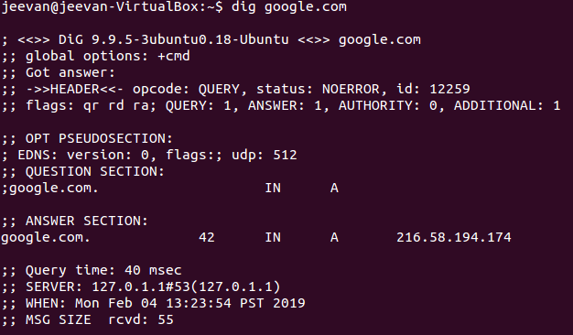

**Telnet**

To check connectivity between two hosts.

telnet hostname portno

**NSLOOKUP**

To find entries on the DNS servers

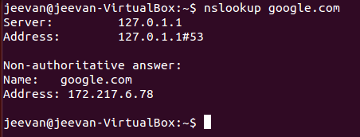

**NETSTAT**

Summary of all ports connected and their status

**W**

Summary of current activity on the host

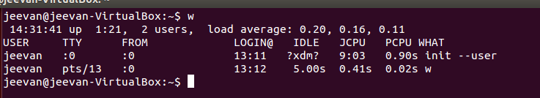

**NMAP**

Checks the open ports on the server

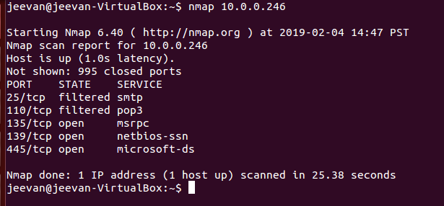

https://www.tecmint.com/nmap-command-examples/

**IFUP / IFDOWN**

To enable or disable a network interface.

Example

Ifup eth0

Ifdown eth0

**SCP**

Secure copy files from other hosts in the network

**ARP command**

ARP table on the host machine

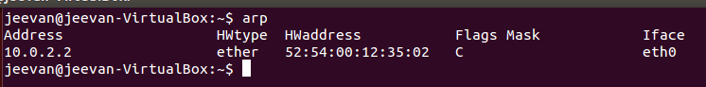

**Route Command**

Routing table on the host machine

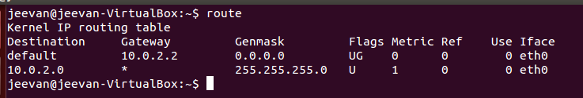

Adding a default gateway

route add -net <ipaddress> gw <gateway ipaddress>

default gateway

route add default gw <gateway ip address>

**HOST Command**

Name to ip and Ip to name

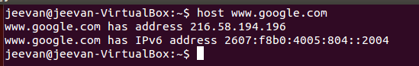

**Security commands**

Checksum – used to validate integrity of our files

Command: cksum <filename.txt>

Output 🡪 checksum , size in bytes, filename